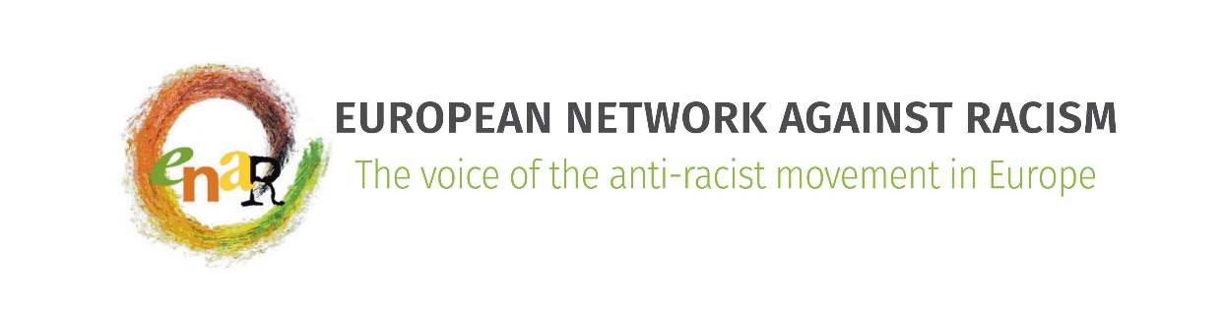

**Who is who**

**on the**

**ENAR Board**

**September 2019**

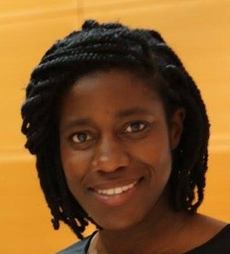

**Karen Taylor, ENAR Chair**

**EOTO (Each One Teach One), Germany, Northeast**

**Expertise:** Anti-Black racism, anti-discrimination policies, UN Decade for people of African descent, advocacy

Karen served two years as Ordinary Board Member.

[Karen.taylor@outlook.de](mailto:Karen.taylor@outlook.de)

Languages: German, English, French

**Ghislain Vedeux, ENAR Vice Chair**

**CRAN, Conseil Représentatif des Associations Noires, France, Southwest**

**Expertise:** Hate crime and police brutality, discrimination, afrophobia, slavery-colonialism and reparations, sport, education

Ghislain served two years as Ordinary Board Member.

[messy@hotmail.fr](mailto:messy@hotmail.fr)

Languages: French, English

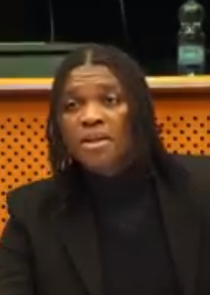

**Amiirah Salleh-Hoddin, ENAR Vice Chair**

**Anti-Racist Forum, Finland, Northeast**

**Expertise:** Critical anti-racism, intersectional activism, research (quantitative & qualitative), equality data, anti-racism/global education, interfaith coalitions

[amiirah@antiracistforum.org](mailto:amiirah@antiracistforum.org)

Languages: Finnish, English

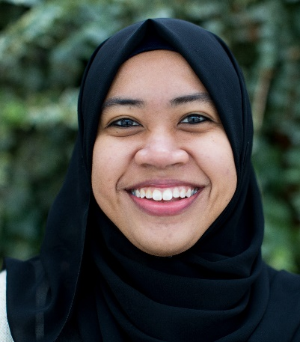

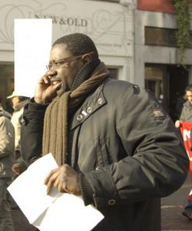

**Wouter Van Bellingen, ENAR Treasurer**

**Integratiepact, Belgium, Northwest**

**Expertise:** Integration, discrimination, racism, migration, education, work, equal opportunities, diversity

Wouter served three years as Treasurer.

[wouter.vanbellingen@integratiepact.de](mailto:wouter.vanbellingen@integratiepact.de)

Languages: Dutch, English, French

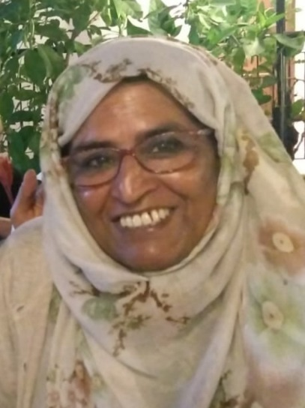

**Zlakha Ahmed, ENAR Board Member**

**Apna Haq, United Kingdom, Northwest**

**Expertise:** Religious minorities

[Apnahaq1@gmail.com](mailto:Apnahaq1@gmail.com)

Lauangues: English

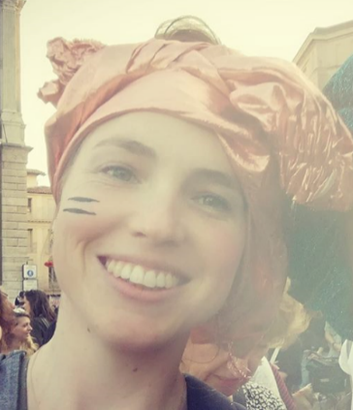

**Giulia Lola Frova, ENAR Board MemberIl Razzismo è una brutta storia, Italy, Southwest**

**Expertise:** Critical whiteness, trans-feminist intersectional work,

anti-racism education and cultural promotion, campaigning, performing arts (puppetry!) for social justice, corporate responsibility

giulia.frova@razzismobruttastoria.net

Languages: Italian, English

**Maria Dexborg  
Pan African Movement for Justice, Sweden, Northwest**

**Expertise:** Anti-racism, Afrophobia, gender equity/feminism, advocacy, mobilization

Maria served one year as Ordinary Board Member.

Languages: Swedish, English

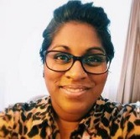

**Shaban Sidratu Jay Sesay, ENAR Board Member  
European Network of Women of African Descent, Spain, Southwest**

**Expertise:** Global governance, private equity, corporate governance, human rights defender, ethnic minorities, afrophobia, discrimination, education, intersectionality, hate

speech and immigration

Shaban103@yahoo.co.uk

Languages: Catalan, Spanish, English

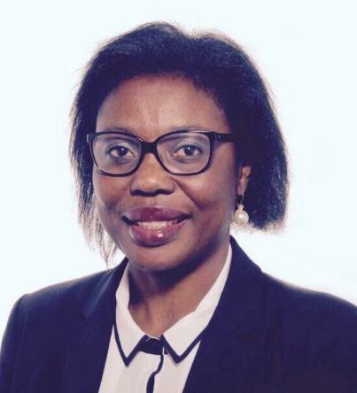

**Laurentia Mariana Mereuta  
AEPADO, European Association for the Defense of Human Rights, Romania, Southeast**

**Expertise:** Human rights, EU law and international public law

Laurentia served two years as Ordinary Board Member and three years as Vice Chair.

Languages: Romanian, English

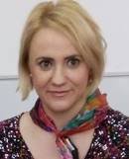

**Marcell Lőrincz  
Subjective Values Foundation, Hungary, Southeast**

**Expertise:** Managing projects and campaigns in the field of migration and Roma, NGO fundraising, good knowledge of the NGO sector on international level

Marcell served two years as Ordinary Board Member and three years as Vice Chair.

Languages: Hungarian, English, Russian

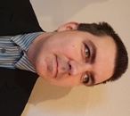

**Vilana Pilinkaite-Sotirovic  
Center for Equality Advancement, Lithuania, Northeast**

**Expertise:** Equality policies, intersectionality, gender and ethnicity, migration and refugee integration

Vilana served four years as Ordinary Board Member.

Languages: Lithuanian, English, Russian

