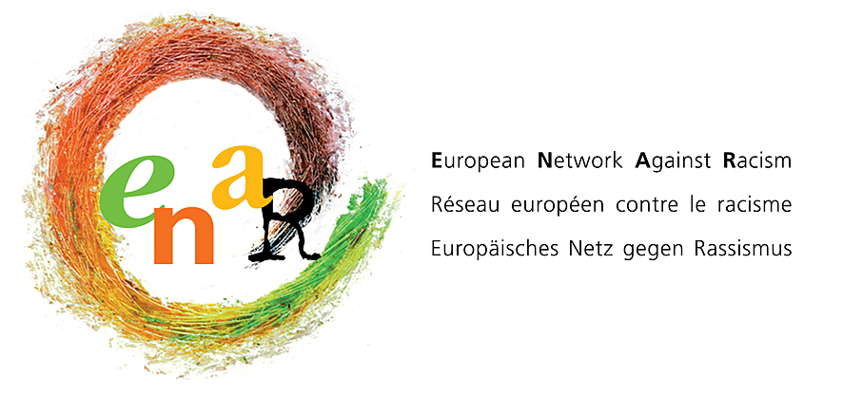 | FINAL DRAFT  Staffing and Finance Sub-committee  Terms of Reference and  Protocols of Operation

- TERMS OF REFERENCE

The Staffing and Finance Sub-Committee (SFSC) is the committee that supports the secretariat with various issues regarding Human Resources, Staffing, Financial matters and Funding. The committee is to engage with the management team of the secretariat and bring all matters needing decisions or resolution to the Board.

Who constitutes the SFSC?
The sub-committee is to be formed up to 5 board members maximum. The Board Members involved are:
- The Chairperson
- A Vice chair
- The Treasurer
- Board Members selected for their experience, knowledge and expertise in the areas of HR/Staffing and Finance

The Director and other members of the management team participate in the meetings when relevant, and may be ask to leave the room should the sensitivity of the conversation require it.

- The SFSC members are identified and a motion is passed by the Board agreeing that these individuals represent the Board in this sub-committee and that they are trusted to bring issues to the Board when appropriate.
- The SFSC is to be chaired by the Chairperson of ENAR. In case of absence of the Chair, the Treasurer will chair the meeting.
- In some extraordinary circumstances urgent decisions need to be made, the Director will contact the Chair and Treasurer of the SFSC who will ask the Board for a motion giving the SFSC authority to act swiftly on behalf of the Board.

Role of the SFSC:
- This space is used to discuss all matters linked to Finance and Staffing and seeks to give support to the secretariat.
- The sub-committee is to be a space for the secretariat to bring any concerns, grievances, issues, questions or any other particular relating to HR, Staffing and finances, according to the process spelled out in the Operating Manual and Labour regulations.
- All matters that need a decision are to be presented by the SFSC to the Board.
- All matters that need approval are to be presented by the SFSC to the Board.
- A summary of the activities of the SFSC is to be reported on at each Board meeting.

Communication:
- The SFSC is to keep regular contact with the management team via grouped email.
- Any conversation regarding matters that would be normally an agenda topic of the SFSC, happening between 2 or more of its members, is to be transcribed into an email to inform the rest of the SFSC.
- The SFSC is to meet when necessary and agreed by all SFSC members and when possible before the Board meetings, at least 3 times per year.
- No member of the SFSC is to contact the staff directly, for SFSC related matters, unless expressly asked to do so from the SFSC and all communication needs to be shared with at least the Chairperson if of highly sensitive nature.

General considerations:
- All matters discussed in the SFSC especially relating to Staffing are to be considered highly confidential. If the information is deemed sensitive by the SFSC, in view of the protection of any party involved, the SFSC might not disclose all details to the Board. The SFSC will act in good faith.
- If the matter is one that necessitates legal advice or information relating to Belgium law (to which ENAR is subject) the SFSC will seek assistance.
- The SFSC is a group established to support the staff in their work and will reinforce our values as an organisation to be an equal and fair employer.
- The priority of the SFSC is to support the development and maintaining of the best practice in matters of fair and equal employment in line with non-discrimination, workers’ rights and entitlements.

