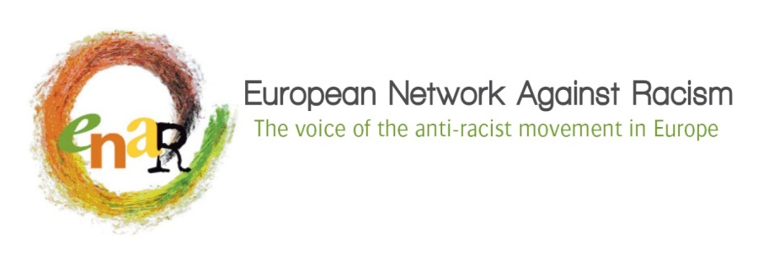

PROJECT PROPOSAL FOR ENAR

for members’ projects to support a vibrant and strong anti-racism network
Please fill in all the questions and follow the current structure

NAME OF PROJECT

PERIOD OF PROJECT IMPLEMENTATION

NAME OF THE ORGANISATION

CONTACT PERSON

CONTACT INFORMATION

MAIN AREA OF WORK

1. Summary of project: please explain the project’s main objectives and activities.

2. Description of the organisations that are participating to the project/activities.

3. Purpose of activities

- Which are the project objectives, beneficiaries and stakeholders involved?

- Please describe how will the project objective(s) support the overall mission of ENAR and specifically its objectives as described in ENAR 2018-2021 strategic objectives?

- What are the expected results and what is the expected impact?

- How will your initiatives contribute to strengthening your cooperation with other members of ENAR in your country or your region or with the overall network?

4. Project Activities
4.1 Detailed activities
Please explain the context of the activities. Please provide the necessary information such as the objective of the activity, the expected outcome and outputs, the beneficiaries and the stakeholders involved.

4.2 Timeframe
Please describe the calendar of activities throughout the project.

5. Evaluation and impact

- How will you evaluate your activities in order to measure the impact of your project?

- What is the organizational structure to fulfill objective of the project?

- What are the risks that this project could be confronted with?

- In what way does your activity fit into the strategies of ENAR and how will the outcome of your activity lead to achieving the outcome that we want to meet?

- How will you measure project impact (e.g. how will the project help to attain the goal of ENAR strategy)?

