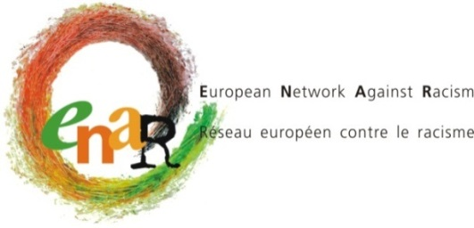

ENAR BOARD MEETING
Meeting with local organisations
ENAR Ireland meeting: “National Action Plan Against Racism”

Dublin, 30 -31 March & 1st April 2017

INFORMATION SHEET

Board and staff members arrive on Thursday, 30 March in Dublin with the exception of Claudia, Wouter and Anne-Sophie (arriving on Wednesday, 29 March).

30 March: At 13.00, we will meet in the hotel lobby of Jurys Inn for lunch.
In the afternoon, we will have informal meetings with NGO's and activists and a briefing session on the seminar.

31 March: In the morning, we will participate in the session on “NATIONAL ACTION PLAN AGAINST
RACISM” at IHREC Venue, 16-22 Green Street, Dublin 7.
The meeting venue is 10 minutes’ walk from the hotel. We will meet at 8.45 in the lobby to leave together.
The afternoon programme will be communicated to you by Amel later on.

1St April: We start the board meeting at 9.00 in Cathal Brugha Room, on the second floor.
The end is planned at 16.15.

ACCOMMODATION & Board meeting venue (FOR ALL from 29 March to 1 April)

Jurys Inn Parnell Street
Moore Street Mall, Parnell St,
North City, Dublin 1,
D01 E0H3, Ireland
Phone: +353 1 878 4900

ONLY LAURENTIA, JAMIE AND ENRIQUE WILL STAY AT JURYS INN FOR THE NIGHT OF APRIL 1st.

Maldron Hotel: (Night of April 1st for Myriam, Karen, Michael, Wouter, Claudia, Peter)
Dublin Airport
Corballis, Dublin
Phone: +353 1 8080500

The hotel is located ten minutes’ walk from the airport.

Anne-Sophie mobile phone for emergency: +32 474 44 25 47

HOW TO GET TO THE HOTEL FROM THE AIRPORT?

- Option 1: Dublin Bus “747”

Take the bus 747 direction “Heuston stn” from Dublin Airport, and stop at: “Dublin Cathal Brugha Street”. When you step down the bus, continue to walk on “Cathal Brugha Street” (100m) and turn right on “O’Connell Street”(79m). Turn left onto “Parnell Street” (170m). Your Destination will be on the left. Price: € 6 one way. No return ticket at cheaper price available. Bring cash.
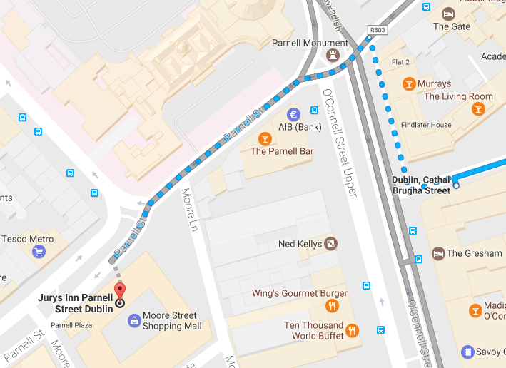

- Option 2: Aircoach

Take the aircoach from the terminal 1&2 direction “Dublin City-Leopardstown”. Stop at “O’Connell Street”. Head straight on “O’Connell Street”(79m). Turn left onto “Parnell Street” (170m). Your destination will be on the left. Price: € 6 one way or € 11 return. Bring cash.
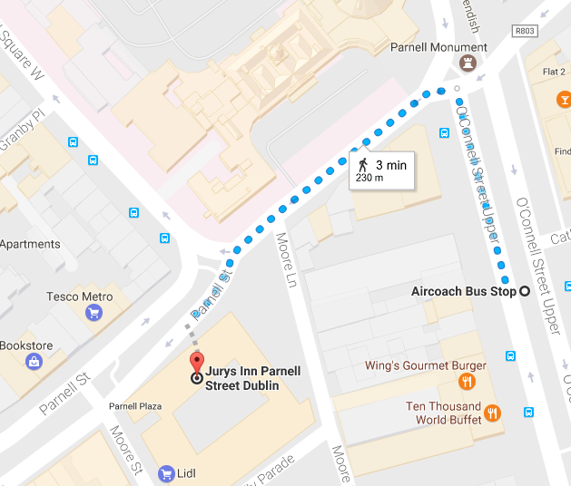

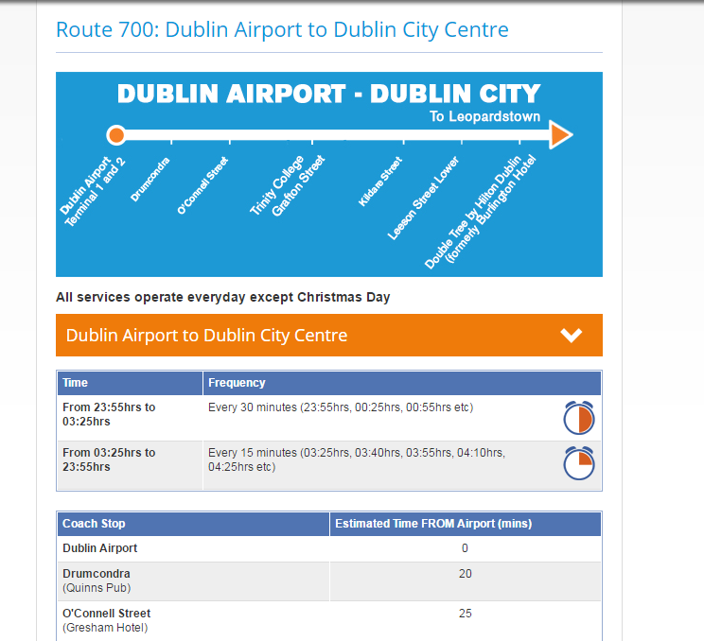

HOW TO GO FROM THE HOTEL TO FRIDAY MEETING VENUE?
Head left on Parnell Street toward Moore Street (400 m). Slight right onto Ryder's Row (97 m) then slight right onto Capel Street (100 m). Turn left onto Bolton Street (49 m) and slight left onto Green Street. Destination will be on the left.

How to get to the Maldron Airport hotel on the 1st April?
Take the Aircoach back to the airport then walk less than 10 minutes:
REIMBURSEMENT

ENAR pays for each participant 3 or 4 nights of accommodation and catering during the meetings.
Personal expenses such as phone calls, emails, mini-bar, extra meals, laundry, etc… will be charged by the hotel directly to the participants.

According to European Commission rules, we are only able to reimburse the most direct and economic travel route. Air travel is allowed only for distances above 400 km one way and is limited to special airfares, such as Apex tariffs. We can not reimburse tickets that were not used.

For calculating the exchange rate, you must use the rate as publicized on the EC website:
http://ec.europa.eu/budget/inforeuro/

For those travelling by train, please note that only 2nd class train tickets can be reimbursed.

Travel costs will be reimbursed upon completion of an expense claim form which will be made available at the meeting or online and upon presentation of original receipts (train or plane ticket with indication of the price and boarding passes). Expense claims must be returned to ENAR Aisbl before 25th December 2017 or we won’t be able to reimburse you.

Excess travel costs for which the Secretariat did not receive a request in advance will not be reimbursed. Taxi receipts are not eligible. Please note that metro and tram tickets will be reimbursed by ENAR.

The use of a private car is reimbursed per car and not per person in the car to the value of a 2nd class return train ticket from point of departure to the meeting venue.

Conduct during meetings

By registering to this upcoming ENAR meeting, you reconfirm your agreement with ENAR’s code of conduct at ENAR meetings and any evening events linked to ENAR meetings (including individual/group visits to downtown pubs/bars).
ENAR members or any participant at ENAR meetings are expected to contribute to an atmosphere of positive and constructive friendliness and respect for each other during the meetings and debates, including during the breaks and evening events. Insulting, abusing, offending or intimidating behaviors will not be allowed. During the meetings, name calling, violent or excessively aggressive language, racist, sexist or any other kind of discriminatory remarks, behavior including harassment or language, shall be sanctioned by the Chair of the session according to ENAR’s procedures.
Sexual harassment occurred during ENAR meetings and random evening events (including individual/group visits to downtown pubs/bars), will be sanctioned by the Board by excluding the perpetrator(s) to all future ENAR meetings organized by the ENAR secretariat.
Board Members, staff members, interns and any other individual or collective member of ENAR, which feels insulted, defamed or harassed by any other has a right to call for protection of her/his dignity according to procedures established in ENAR’s internal manual.

