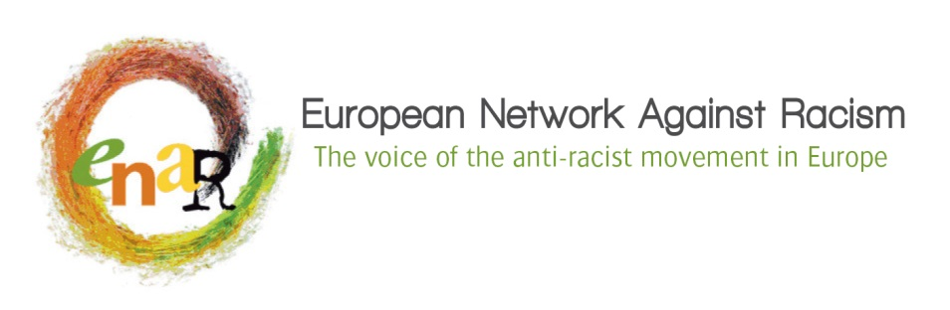

Adopting the ENAR Strategic Plan 2018-2020

Draft process – General Assembly of 24 June 2017

Time frame: 30 January 2017 – 24 June 2017

What: ENAR adopts 3 years Strategic Objectives that frame the activities of the Network. On that basis, the Board and the Secretariat will elaborate detailed yearly work plans that are adopted by the General Assembly.

Since 2014, ENAR has moved away from adopting detailed Strategic Plans that are difficult to develop, complex to assess and vote for by members and can become straight jackets preventing the adaption of the organisation to emerging challenges as new votes will be necessary to adapt the course of the organisation. As a pan-European organisation, gathering votes at short notice can become a challenge likely to severely impede the functioning of the Network and the adjustment to unexpected situations.

A good example is what happened in the course of the current Strategic Planning exercise. In June 2014, Members adopted the current set of strategic objectives, but none of them was specifically concerned by policing, counter-terrorism measures, etc. The consequences of terror attacks on European policies after January 2015 have impacted so massively a number of minority communities (Muslims, People of African Descent and Black Europeans, migrants and Jews) that ENAR had to re-adjust entirely its action plans. The flexibility of our governance model based on the adoption of a limited set of Strategic Objectives framing our yearly activities has catered for a quick adjustment of ENAR’s work to cope with this emerging challenge.

How: based on experience, it is recommended to have at least 2 rounds of consultation of the membership to ensure that everybody has had a fair opportunity to look at the document to be adopted at the General Assembly and contribute with comments, suggestions, improvements, amendments. The aim is that the GA is presented with a consolidated document outlining the Strategic Objectives and that it adopts the Strategic Objectives directly. Debate should be limited around potential amendments stemming from the last round of consultation.

This year, the process will be devised to be as participatory as possible, with more opportunities for members to engage in the process, rather than only commenting on documents. We will ensure that there will be a broader spectrum of means and opportunities to contribute, corresponding better to the various situations of the members and their capacities to engage in the process.

The Members will contribute to the development of ENAR’s overall Theory of Change. Its development will be nurtured by the consultation process, but it will not be voted upon has such a document is constant “work in progress”. Only the Strategic Objectives will be subject to a vote of endorsement by the General Assembly in June 2017.

Outline of the process:

What? | When? | Who? | Remarks
- Consultation of the membership through working groups during the General Assembly | June 2016 | - Board  - Members  - Secretariat | Achieved
- Developing the 1st draft of Theory of Change (ToC) and Strategic Objectives (SO) | December 2016 | - Secretariat | Achieved
- Brainstorming session with Board and Secretariat on strategic planning | December 2016 | - Secretariat  - Board  - Facilitated by external consultant | Achieved
- Developing a 2nd draft of ToC and SO | January 2017 | - Secretariat | Achieved
- Reviewing the 2nd draft of ToC and SO | 28/01/17 | - Board | Achieved
- Circulating the 2nd draft of ToC and SO to the Members (1st round) | 03/02/17 | - Secretariat
- Providing amendments and feedback on the 2nd draft of ToC and SO | 17/03/17 | - Members | Members will have the opportunity to provide feedback and contributions under different formats:  - Using the consultation document with track changes/comments  - Specific template designed by the Sec accessible on Google Drive  - Clustered online conversations on each specific SO as of 20/02 (Skype or conference call) // a dedicated timing will be provided by the Secretariat  - ENAR Members FB page where the specific SO will be open for comments  - Direct calls/mails to Juliana or Michael
- Compiling the feedback of the 1st round of consultation | 20/03/17 | - Secretariat
- Sending the 3rd draft of ToC and So to the Board | 24/03/17 | - Secretariat
- Reviewing of the 3rd draft of ToC and SO by the Board | 31/03/17 | - Board
- Circulating the 3rd draft of ToC and So to the Members (2nd round) | 07/04/17 | - Secretariat
- Providing amendments and feedback on the 2nd draft of ToC and SO | 07/05/17 | - Members | Members will have the opportunity to provide feedback and contributions under different formats:  - Using the consultation document with track changes/comments  - Specific template designed by the Sec.  - Clustered online conversations on each specific SO as of 17/04 (Skype or conference call) // a dedicated timing will be provided by the Secretariat  - ENAR Members FB page where the specific SO will be open for comments  - Direct calls/mails to Juliana or Michael
- Compiling the feedback of the 2nd round of consultation | 08/05/17 | - Secretariat
- Circulating the final draft of the ToC and the SO for adoption | 12/05/17 | - Secretariat
- Adoption of the SO | 24/06/17 | - Members

