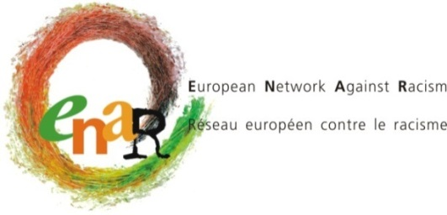

ENAR BOARD MEETING

BRUSSELS, 23-24 SEPTEMBER 2016

INFORMATION SHEET

Welcome at ENAR. The induction meeting for the new Board members starts at 9:30. Please come in by 9:20 at the latest. On Saturday, the Board meeting will start at 9:15.

ACCOMMODATION & VENUE OF THE MEETING

Motel One Bruxelles  Rue Royale 120  1000 Bruxelles  +32 2 209 61 10 | ENAR Office  Rue Ducale 67  1000 Brussels  +32 2 229 35 70

DIRECTIONS:

From the Brussels airport (Zaventem) to the hotel

Inside Brussels airport, go to the train station.
Take any train going to or through Brussels. All have a stop at BRUSSELS CENTRAL (Bruxelles central – Brussel Centraal).

Get out at the BRUSSELS CENTRAL station (the ride is approximately 17 minutes).

From the central train station (Gare Centrale – Brussel Centraal) to the hotel

Take the exit “Carrefour de l’Europe” / “Europakruispunt”
Head east on Putterie/Putterij street towards Cantersteen/Kantersteen street
Turn left onto Cantersteen/Kantersteen street
Continue onto Rue des Colonies/Koloniënstraat untill you see the Royal parc
Turn left onto Koningsstraat/Rue Royale The destination will be on the left

FROM THE HOTEL TO THE OFFICE: 7 minute walk
Turn right while exiting the hotel. – Rue Royale/ Koningsstraat
Cross the street and take the second street on your left: Rue de Louvain/ Leuvenseweg
Turn on the first street on your right: Rue de la Presse/Drukpresstraat
Straight ahead, you will arrive on Rue Ducale/ Hertogsstraat, the destination will be on your left. N°67

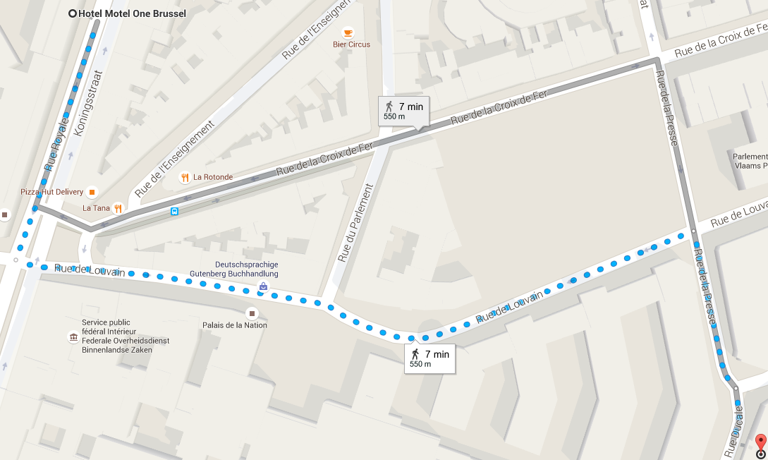

From the MIDI train station (Gare du midi – Zuid Station) to the Office
Take the subway line 2 or 6 direction “Elisabeth”
Get off at Arts-Loi/Kunst-Wet station and use the Exit “Boulevard du régent”
Go directly right on Rue de la Loi. At the first corner, turn right on Rue Ducale.
Walk 2 minutes and the destination will be on the right.

From the MIDI train station (Gare du midi – Zuid Station) to the Hotel

Take the subway line 2 or 6 direction “Elisabeth”
Get off at Arts-Loi/Kunst-Wet station and use the Exit “Boulevard du régent”
Continue to follow the Rue de la Loi/ Wetstraat
Turn right onto Koningsstraat/Rue Royale.
The destination will be on your left.

HOTEL

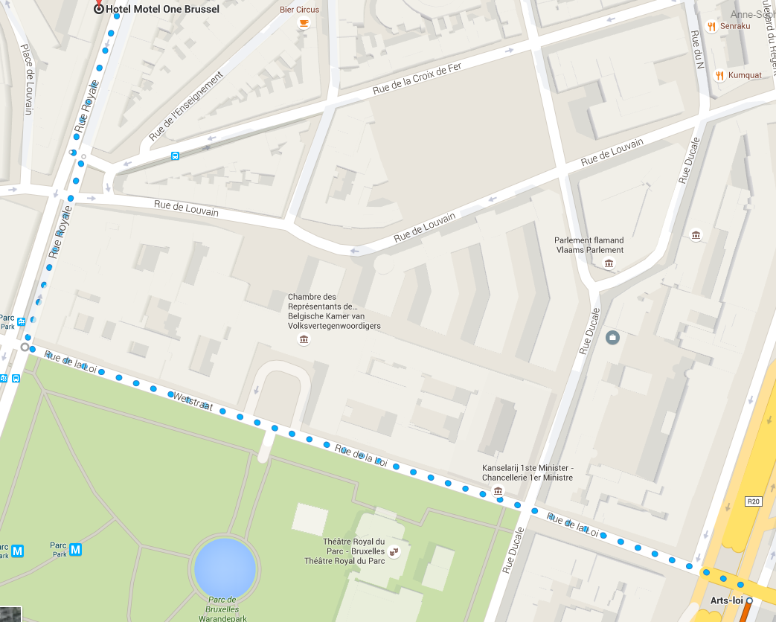
ENAR OFFICE
REIMBURSEMENT

ENAR pays for each participant 2 or 3 nights of accommodation and catering during the meeting.
Personal expenses such as phone calls, emails, mini-bar, extra meals, laundry, etc… will be charged by the hotel directly to the participants.

According to European Commission rules, we are only able to reimburse the most direct and economic travel route. Air travel is allowed only for distances above 400 km one way and is limited to special airfares, such as Apex tariffs. We can not reimburse tickets that were not used.

For calculating the exchange rate, you must use the rate as publicized on the EC website:
http://ec.europa.eu/budget/inforeuro/

For those travelling by train, please note that only 2nd class train tickets can be reimbursed.

Travel costs will be reimbursed upon completion of an expense claim form which will be made available at the meeting and upon presentation of original receipts (train or plane ticket with indication of the price and boarding passes).

Excess travel costs for which the Secretariat did not receive a request in advance will not be reimbursed. Taxi receipts are not eligible. Please note that metro and tram tickets will be reimbursed by ENAR.

The use of a private car is reimbursed per car and not per person in the car to the value of a 2nd class return train ticket from point of departure to the meeting venue.

CONDUCT DURING MEETINGS
By registering to this upcoming ENAR meeting, you reconfirm your agreement with ENAR’s code of conduct at ENAR meetings and any evening events linked to ENAR meetings (including individual/group visits to downtown pubs/bars).
ENAR members or any participant at ENAR meetings are expected to contribute to an atmosphere of positive and constructive friendliness and respect for each other during the meetings and debates, including during the breaks and evening events. Insulting, abusing, offending or intimidating behaviors will not be allowed. During the meetings, name calling, violent or excessively aggressive language, racist, sexist or any other kind of discriminatory remarks, behavior including harassment or language, shall be sanctioned by the Chair of the session according to ENAR’s procedures.
Sexual harassment occurred during ENAR meetings and random evening events (including individual/group visits to downtown pubs/bars), will be sanctioned by the Board by excluding the perpetrator(s) to all future ENAR meetings organized by the ENAR secretariat.
Board Members, staff members, interns and any other individual or collective member of ENAR, which feels insulted, defamed or harassed by any other has a right to call for protection of her/his dignity according to procedures established in ENAR’s internal manual.

