Looking back and ahead: ENAR’s impact in 2015 and plans for 2016

In 2015, ENAR was extremely busy advancing equality and social justice for ethnic and religious minority individuals in Europe.

2015 was a tough year: the dire conditions for refugees and migrants arriving to Europe, the tragic terrorist attacks in Paris, the growing polarisation of our societies and the disproportionate impact these events had on vulnerable individuals, including ethnic and religious communities.

But it was also a challenging year in the sense that ENAR was in the right place at the right time to provide analysis, vision, concrete policy proposals, and to help decision makers and journalists make sense of these events and react according to Human Rights based approaches.

Our impact materialised - among many other things - around the first EU Fundamental Rights Colloquium focused on Antisemitism and Islamophobia, where ENAR was involved at all stages: in terms of framing content, interacting with various civil society and institutional actors and ensuring that our members were present and their priorities taken on board.

2015 has definitely confirmed that the long and painful process of strategical repositioning - I would even say rebirth - that we undertook in 2011-12 is now starting to pay off - and it’s only the beginning.

2016 will therefore be a continuation and strengthening of our advocacy work of 2015:
- Calling for concrete actions from EU institutions and Member States on Antisemitism and Islamophobia, now that the EU has taken a great first step in this direction.
- Ensuring that Anti-Gypsyism and Afrophobia start to receive the same level of attention as critical stumbling blocks in the cohesion of our societies.
- Supporting the European Commission in developing guidelines for Member States on equality data collection to ensure clear monitoring of inequalities and progress towards equality.
- Supporting the development of progress indicators of the inclusion of ethnic minorities and migrants in the labour market and subsequent policy measures to achieve progress.
- Continuing to empower civil society activists to bring local change that can have a larger impact up to the European level. This year will bring special attention to different projects: Muslim-Jewish initiatives aiming at building things together for the common good; and joint Muslim women & mainstream feminists initiatives at the local level aiming to close gaps between movements fighting for equality between women and men.

Michaël Privot, ENAR Director

7 highlights from 2015
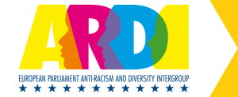
A stronger and more visible Anti-Racism and Diversity Intergroup in the European Parliament: Thanks to ENAR and partners’ active involvement, the intergroup was officially established and has seven thematic working groups.

The European Commission committed to guidelines on equality data collection: As a result of concerted efforts by ENAR and others since 2013, the Commission’s conclusions from the Colloquium on Fundamental Rights recommend Member States to “tackle gaps in monitoring discrimination” and refer to the need for tools, guidance and (…) peer learning to support Member States' efforts in the collection of equality data”.

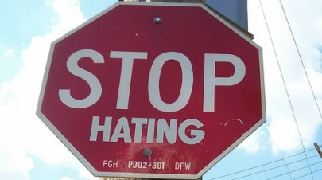
The European Commission committed to compiling best practice guidance for Member States on effective implementation of EU hate crime law: The idea of guidelines on hate crime standards is mentioned in the Conclusions from the Fundamental Rights Colloquium and follows advocacy by ENAR and partner organisations.

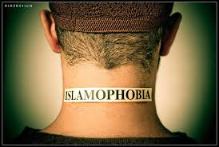
European Institutions took steps to recognise and combat Islamophobia: The European Institutions have dedicated high-level events to combating Islamophobia for the first time ever. High-level politicians and decision-makers have recognised the reality of Islamophobia and the urgency to act. The European Commission has also appointed an EU coordinator on Islamophobia. The need for national strategies to combat Islamophobia has been aired by the European Commission and the European Parliament.

European bodies made some commitments to recognise Afrophobia: The EU Fundamental Rights Agency publicly committed to look specifically at the situation of people of African descent. Both the Dutch and Swedish governments, thanks to the mobilisation of ENAR members in these countries, have committed to either dedicated plans/strategies taking into account the specificity of Afrophobia or action plans for the UN Decade for people of African descent.
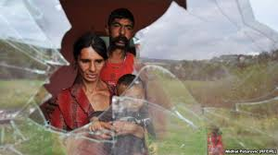
Increased recognition of anti-Gypsyism as an obstacle to implementation of inclusion policies for Roma: ENAR and the pro-Roma NGO coalition have succeeded in putting anti-Gypsyism on the European Commission and the European Parliament’s priority map for Roma inclusion.

Re-affirmed mobilisation on Antisemitism: ENAR’s advocacy regarding Antisemitism this year led to reinforced cooperation with members and other organisations, and the European Commission appointing an EU coordinator on Antisemitism. The need for national strategies to combat Antisemitism has also been aired by both the European Commission and the European Parliament.
What ENAR plans in 2016

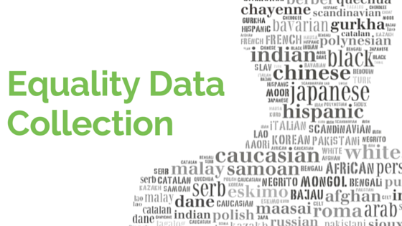
ENAR has been advocating for the European Commission to issue guidelines to Member States on how to collect safe and inclusive data to measure discrimination. This year, we will organise an event in the European Parliament to build leadership across EU institutions on equality data collection. We will also make sure that the launch of the European Commission handbook is made a powerful advocacy opportunity for the antiracism movement and the EU institutions to change to national practices.

Some members are working nationally to build the understanding for data collection among communities at risk of discrimination and among decision-makers.

ENAR will continue advocating for the European Commission to produce hate crime EU law guidance and for the FRA to produce good practices compendia on States' response to hate crime. Together with the ARDI and LGBTI intergroups In the European Parliament, ENAR is building on the Parliament’s support to EU law enhancement and completion: we will work with MEPs to ensure that they go beyond their existing proposal and propose a fully-fledged legislative and policy model, addressing all key questions including the legal basis for a new legislative phase. This in turn will increase pressure on the Commission to propose an improved hate crime legislation to cover all forms of hate crime, and on the most favourable Member States to champion this cause in the Council.

Some members have worked to improved their data collection methodologies on racist crime and, on the basis of their results, have advocated for better responses to this form of crime by States.

The European parliament is currently revising its Rules of Procedures. ENAR and partners have been advising the dedicated working Group to propose stricter and more dissuasive administrative sanctions against MEPs using hate speech in the European Parliament. We have also worked on a civil society monitoring system for reporting hate speech in the institutions, which should be beefed up.

Members are encouraged to monitor and report political hate speech and incitement to hatred, especially if there are elections in 2016 in your country.

We continue advocating for the removal of labour market barriers affecting ethnic and religious minorities including migrants. This year we will hold a steering group on employment indicators with specialists and representatives of communities. In December, we will hold the annual Equal@work seminar on diversity management with business, trade unions and NGOs partners. We will also produce a toolkit on inclusion of religious diversity at the workplace.

Some members have been active in our Equal@Work platform and will carry out specific projects in the field of discrimination in employment or diversity management.

2015 has seen security issues back at the forefront of polices in the EU and its Member States, as the result of violent terrorist attacks in Europe. ENAR will engage at EU and national levels to ensure trust building and inclusive security and policing policies grounded in long term social inclusion. We are following the adoption of the new proposed EU directive on combatting terrorism. We also will co-organise an event on ethnic profiling in the EU in the European Parliament.

Many members have monitored and condemned the negative impact of some counter-terrorism policies on the communities they work with, and/or have focused on fair and efficient police practices.

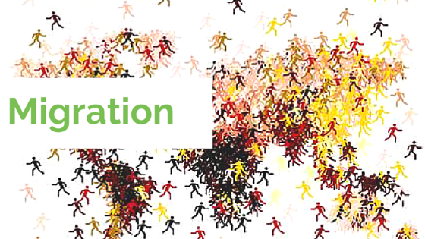
The current asylum and migration 'crisis' in the European Union reveals structural problems in the EU’s response to an emergency situation. ENAR supports ongoing efforts for safe and legal entry and reception conditions for migrants and asylum seekers. We would also like to raise the attention to high levels of structural islamophobia, anti-migrant racism and populism as well as long-term implications for European societies. We will focus on integration of migrants including their right to security and non-discrimination, through ongoing EU processes (European Parliament reports, EU Migration and Asylum Forum, EU agenda on migration). ENAR will continue to monitor incidents of racist discourse and violence against migrants in EU Member States, including demeaning speeches by politicians, violence, anti-migrant demonstrations, and discriminatory practices by national authorities.

Members are at the forefront of reception conditions for migrants and asylum seekers. Some have also worked to provide support to long-term integration and security in their host community.

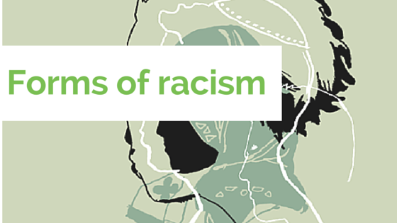
All the above highlights are relevant for different groups victims of discrimination and racism: Muslims, Jews, Roma, people of African descent/Black Europeans and migrants. Some additional specific activities this year include:

- In April, we will launch 8 national reports and one European report on the impact of islamophobia on women during a European conference on Muslim women’s experiences of discrimination in Brussels (Forgotten Women project). Members will be encouraged to launch the national reports in their respective countries, to apply to call for local joint projects related to the inclusion of Muslim women and to join communication campaign around the issue.

- By the end of the year, we will produce ENAR’s 3rd book of the series Anti-Racism in Focus on anti-Gypsyism. Members will be encouraged to submit papers.

- We are continuing regular advocacy meetings at national and EU levels on Antisemitism. Members will join some advocacy meetings.

- The launch of our Shadow Report on Afrophobia will mark the start of a campaign for recognition and justice in the frame of the UN Decade for People of African descent. Members will be invited to join the campaign, by holding their own local activities and supporting common demands.

The need for evidence-based research is ever stronger to support our work at EU and national levels. This year in March, on the occasion of the week against racism, ENAR will launch its latest Shadow Report on Afrophobia in the EU. Our ongoing research, to be published in 2017, will focus on migration policies from an equality perspective (violence and hate speech against migrants, discriminatory policies and practices).

ENAR’s database and research, including European Shadow report and national briefs, support members and partners in establishing a baseline of racial discrimination in Europe.

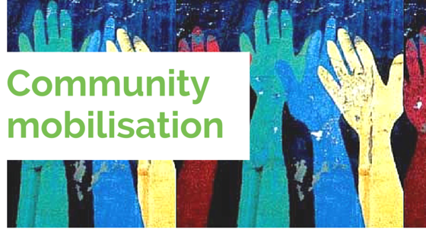
This year, we will continue with dedicated project opportunities for members in areas related to ENAR strategic priorities. We are increasing our efforts to mobilise communities towards positive change. In March, we will hold a training on community mobilisation techniques applied to good practices of cooperation between Jews and Muslims, which will be transferred to two pilot projects throughout the year. ENAR also aims to strengthen its cooperation with other international actors and organisations through local actions with the different groups represented in its network.

Members’ actions and campaigns aiming to mobilise their community can be shared and possibly transferred in the membership.
Disseminating ENAR’s findings and ensuring effective media coverage of ENAR’s strategic priorities continue to be a priority.

Members are invited to share their achievements and priority concerns through ENAR sponsored op-eds, press statements and blogs.

Become a member of ENAR and work with us for equality, solidarity and wellbeing for all in Europe.
Our team is here to answer any questions you may have on these highlights. Check who is who here.

