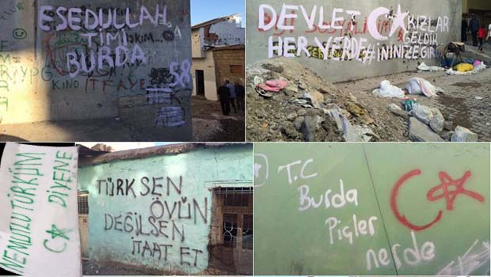
Diyarbakır, Silvan
[The government is everywhere, Girls we are here to enter your cave]
[How happy it is to say that you are a Turk], [If you are a Turk, be proud. If you are not, obey], [The Turkish State is here, where are the bastards]

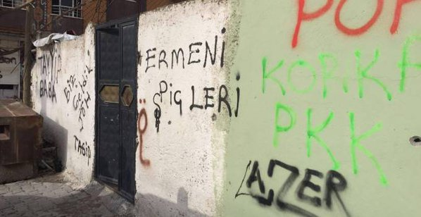
Şırnak, Silopi
[Armenian bastards],[Father Tayyip], [We are here]

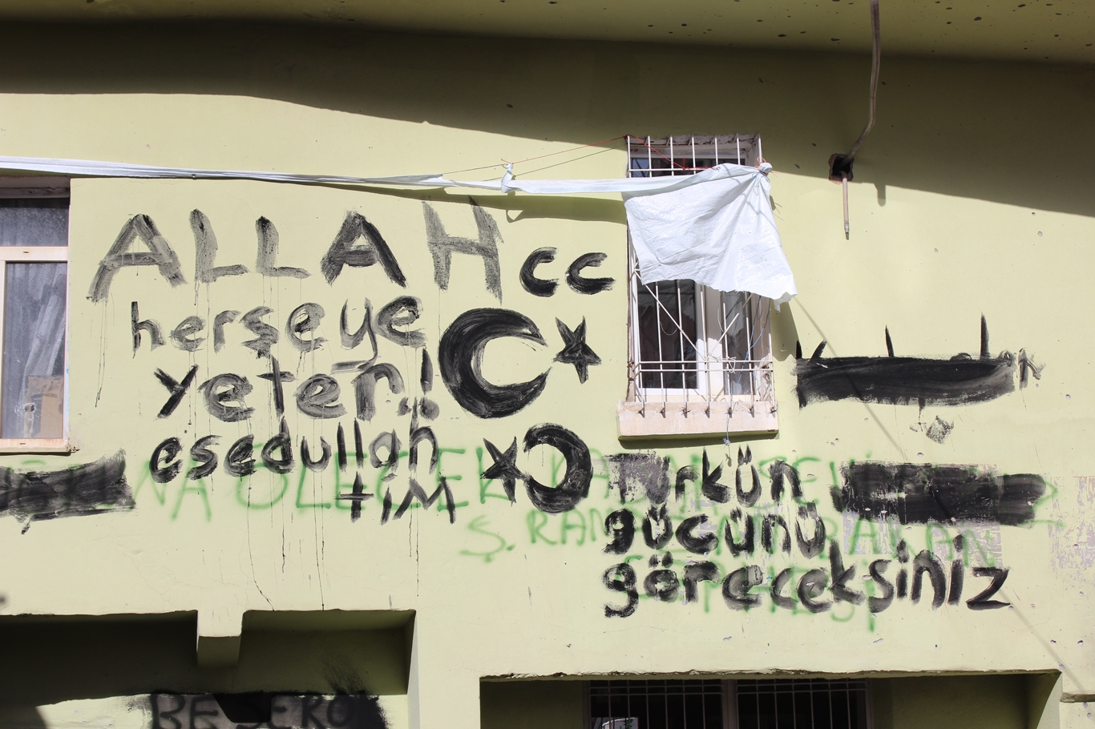
Diyarbakır, Sur
[The God is enough for anything], [You will see the strength of the Turk]
(The symbols represent the Turkish flag and the adopted symbols of racist and nationalist groups in Turkey)

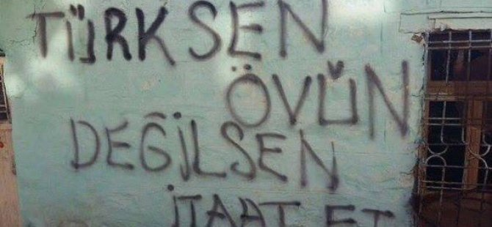
Şırnak, Cizre
[Be proud if you are a Turk, obey if you are not]

