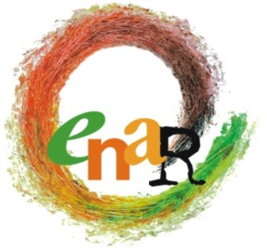

13th BOARD MEETING
AGENDA
Brussels, 27 February 2016

Participants: Sarah, Nicoletta, Andreas, Jamie, Marcell, Vilana, Peter, Intisar
Apologies: Jallow, Laurentia, Amel
Participants ENAR Secretariat: Michael, Claire, Myriam, Officers as relevant
Venue: ENAR Office, 67, rue Ducale, 1000 Brussels
Accommodations: Aloft Brussels

Saturday, 12 September 2015
9:00-17:00

No | Matter | For Information | For Input | For Decision
09:00-09:30 | Opening words  - Adoption of the agenda  - Adoption of the minutes of 12th Board Meeting  Follow up of the decisions of 12th BM  Sarah |  | X | X  X  X
09:30-10:30 | Update on finance, staff and office  (incl. authorization to use the straight loan – tbc)  Myriam | X |  | X  X
10:30-12:45  (incl. coffee break) | GA 2016  - Brainstorming on content with the view to prepare upcoming strategic plan 2018-2020  - Statutory review: 1) mandates of the Board; 2) Membership status |  | X  X
12:45-13:30 | Lunch Break
13:30-16:45  (incl. coffee break) | Membership & content issues:  - Confronting sexism in our structures  - 1. Michael Mc Echrane & Governance issues around Afrophobia  2. Tel Mama, MEND & Islamophobia  - CEJI & Antisemitism  - Working with an intersectional frame & educating about the different forms of racism |  | X  X  X  X  X | X  X  X  X  X
16:45-17:00 | AOB and closing words  - Letter by Turkish NGO  Sarah | X |  | X
17:00 | END OF MEETING

