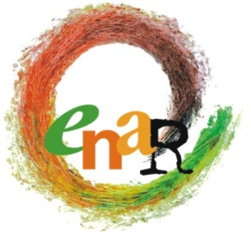

BOARD MEETING
AGENDA
Brussels, 25 June 2015

Participants : Sarah, Nicoletta, Jallow, Laurentia, Jamie, Eyachew, Marcell
Apologies: Rokhaya, Julia, Niels-Erik, Andreas
Participants ENAR Secretariat: Michael, Claire, Myriam, Officers as relevant
Venue: ENAR Office
Accommodations:
- 24 June 2015: Nekotel Concept Art Hotel (Esplanade de L'Europe 27-29, 1060 Brussels)
- 25 June 2015: Thon EU (Rue de la Loi, 75 - 1040 Brussels)

Thursday, 25 June 2015
9:00-17:00

No | Matter | For Information | For Input | For Decision
09:00-09:30 | Opening words  - Adoption of the agenda  - Adoption of the minutes of 9th Board Meeting  Follow up of the decisions of 9th BM  Sarah |  | X | X  X  X
09:30-10:30 | GA Agenda & Programme: day 1  Role of the Board  Claire and Myriam
10:30-11:00 | Coffee Break
11:00-12:30 | GA Agenda & programme: day 2  Role of the Board  - Prezi  - Statutory session  - Members  - Elections  - Outgoing members  Claire, Myriam and Juliana |  | X | X
12:30-13:15 | Lunch Break
13:15-14:30 | Update on Staff  Update on Finances / report on EC meeting  Michael and Myriam | X | X
14:30-16:00 | Network development (ppt)  ENPAD  UN Decade  Michael, Juliana, Ojeaku and Claire | X | X | X
16:00-17:00 | Reflections on a WP for the upcoming Board  Michael and Claire | X | X
17:00-17:15 | AOB and closing words  Sarah | X |  | X
17:15 | END OF MEETING

