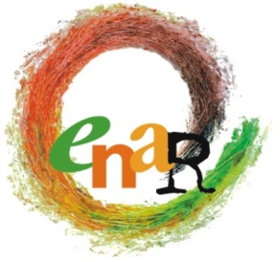

BOARD MEETING
AGENDA
Brussels, 9 May 2015

Participants : Sarah, Andreas, Niels-Erik (by phone), Eyachew, Marcell
Apologies: Jamie, Rokhaya, Nicoletta, Jallow, Julia, Laurentia
Participants ENAR Secretariat: Michael, Claire, Myriam (by phone), Officers as relevant
Venue: ENAR Office
Accommodation: Park Inn Hotel

Saturday 9 May 2015
9:00-17:00

No | Matter | For Information | For Input | For Decision
09:00-09:30 | Opening words  - Adoption of the agenda  - Adoption of the minutes of 8th Board Meeting  Follow up of the decisions of 8th BM  Sarah |  | X | X  X  X
09:30-10:30 | Finances  - Update on financial challenges  Myriam (phone), Andreas | X | X
10:30-10:45 | Coffee Break
10:45-11:45 | - GA Agenda & programme  Michael, Juliana |  | X | X
11:45-12:15 | - The future of UNITED  Marcell, Michael, Juliana | X | X
12:15-13:00 | - Update on the community mobilization strategy  Juliana | X | X
13:00-13:45 | Lunch Break
13:45-15:15 | - Initial reflection on a possible CR/CT strategy (reported from last board meeting)  Michael | X | X
15:15-15:30 | Coffee Break
15:30-16:30 | - Update on the last experts groups (islamophobia, PAD/BE and anti-Semitism)  Sarah, Claire
16:30-17:00 | - AOB and closing words  Sarah | X |  | X
17:00 | END OF MEETING

