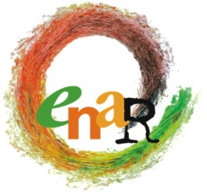

Agenda
8th Steering Committee meeting
7th March 2015

Participants Board meeting: Sarah, Andreas, Niels-Erik, Laurentia, Jamie, Marcell, Eyachew, Nicoletta, Julia
Apologies: Jamie, Rokhaya
Participants ENAR Secretariat: Michael, Myriam, Claire, Officers as relevant
Venue: ENAR Office
Accommodation: Park Inn Hotel

Saturday 7th March 2015
9:00-17:00

No | Matter | For Information | For Input | For Decision
09:00-09:15 | Opening words  - Adoption of the agenda  - Adoption of the minutes of 7th Steering Group meeting  Follow up of the decisions of 7th SGM  Sarah | X | X | X  X  X
09:15-09:30 | Finances  - Update on financial situation:  Andreas and Myriam | X
09:30 – 10:15 | - Shadow Report 2014 and 2015  Ojeaku | X | X
10:15-10:30 | Coffee Break
10:30-11:30 | - Operating Manual  Michael |  | X | X
11:30-13:00 | - After the terror/anti-Semitic attacks of Paris and Copenhagen : ENAR’s approach/upcoming action  Michael | X | X | X
13:00-13:45 | Lunch Break
13:45-15:15 | - Presentation of the Islamophobia and Anti-Semitism strategies  Julie, Claire | X | X
15:15-15:30 | Coffee Break
15:30-17:00 | - Anti-migrant racism, first elements; EPAM  Nicoletta, Eyachew | X | X | X
17:00-17:15 | AOB and closing words  Sarah | X |  | X
17:15 | END OF MEETING

