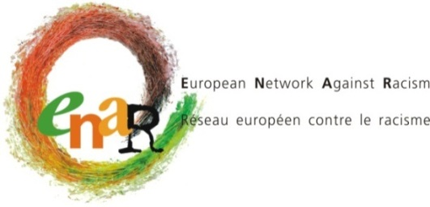

6th BOARD MEETING
27-28 September
ENAR Offices - Brussels

INFORMATION SHEET

The 6th Board meeting is scheduled on Saturday 27 September and Sunday 28 September.
On Saturday, we will welcome you at 9h30. The meeting is scheduled until 17h30.
On Sunday, you are expected at the ENAR office from 9h30 to 16h00.

Arrivals must be scheduled in the evening of Friday 26th September.
All members should be leaving on Sunday 28 September in the evening.
Make sure your plane does not leave before 18h00 from the airport. Trains to Paris or London should not be leaving before 17h00. If on Sunday evening, there is no flight available, please contact Anne-Sophie.

WHO CAN ATTEND?

Board members & staff members.

HOTEL & VENUE OF THE BOARD MEETING

Accommodation:  Park Inn Brussels Midi Hotel.  Place Marcel Broodthaers 3  (Avenue Fonsny)  1060 Brussels Belgium  Tel : 0032 (0)2 535 14 00 | Meeting Venue :  ENAR Office  Rue Gallait, 60 - 3rd floor  1030 Brussels  Tel: 0032 (0)2 229 35 70

HOW TO GET TO THE HOTEL AND TO MEETING VENUE
From the Brussels airport (Zaventem) to the hotel
At the airport, please take the express train direction Brussels and get off at “Gare du Midi“ (Midi Station). The airport train station is located below the terminal (basement level-1). The ticket costs €8.50 (one way). Trains depart every 20 minutes and run from 5 am to midnight. From Gare du Midi, please see paragraph below.

From the train station (Gare du Midi) to the hotel
The hotel is a few steps away from the exit Avenue Fonsny.
When you exit the midi station, cross the road.
The hotel is situated in an inner courtyard across the station exit.

How to get from the train station Gare du Midi to the meeting venue (ENAR office).

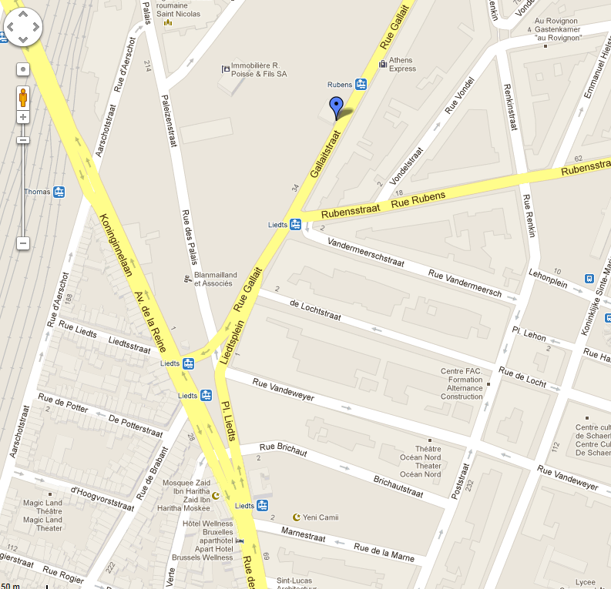
Take tram n° 3 or 4 towards Esplanade or Gare du Nord and get off at GARE DU NORD. Then, walk to Gare du Nord stop to take tram n°25 towards Bondael Gare or Tram N°55 towards Da Vinci. With both trams you can get off at LIEDTS stopTram n°55 stop is in Rue Gallait. Tram n°25 stop is Place Liedts, it’s a 5 minute walk from ENAR Office.
Tram 25
Tram 55
ENAR OFFICE

REIMBURSEMENT

ENAR pays for each Board Member 2 nights of accommodation and catering during the meetings.
Personal expenses such as phone calls, emails, mini-bar, extra meals, laundry, etc… will be charged by the hotel directly to the participants.

According to European Commission rules, we are only able to reimburse the most direct and economic travel route. Air travel is allowed only for distances above 400 km one way and is limited to special airfares, such as Apex tariffs. We can not reimburse tickets that were not used.

For calculating the exchange rate, you must use the rate as publicized on the EC website:
http://ec.europa.eu/budget/inforeuro/

For those travelling by train, please note that only 2nd class train tickets can be reimbursed.

Travel costs will be reimbursed upon completion of an expense claim form which will be made available at the meeting and upon presentation of original receipts (train or plane ticket with indication of the price and boarding passes).

Excess travel costs for which the Secretariat did not receive a request in advance will not be reimbursed. Taxi receipts are not eligible. Please note that metro and tram tickets will be reimbursed by ENAR.

The use of a private car is reimbursed per car and not per person in the car to the value of a 2nd class return train ticket from point of departure to the meeting venue.

